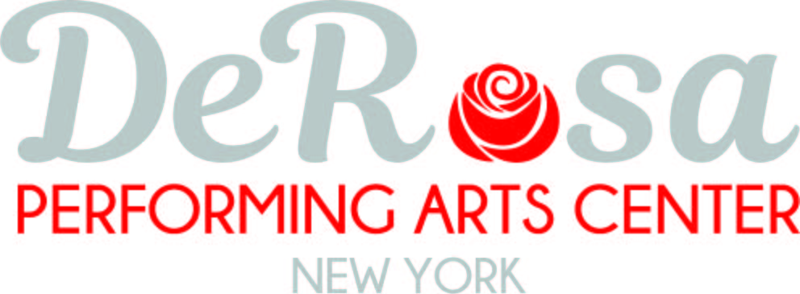

Monday | Tuesday | Wednesday |  | Thursday | Friday | Sunday
3:30-4:30 | 3:30-4:30 | 3:30-4:30 |  | 3:315-4 | 12:30-1:30 | 10-11
Lyrical  Ages 11+  Miss Joanna |  | Hip Hop  Ages 8-10  Miss Joanna |  | Ballet/ Tap  Ages 4-6  Miss Joanna | Ballet  Ages 3-5 | Hip Hop  Ages 3-5 |  | Hip Hop  Ages 6-9
4:30-5:30 | 4:30-5:30 | 4:30-5:30 |  | 4:00-5:00 | 2:30-3:30 | 11-12
DPAC Dolls  Lyrical  Miss Joanna | Jazz  Ages 6-9  Miss Joanna | Lyrical  Ages 6-9  Miss Lauren | Hip Hop  Ages 11+  Miss Joanna | Ballet/ Hip Hop  Ages 5-7 |  | Ballet  3-5
5:30-6:30 | 5:30-6:30 | 5:30-6:30 |  | 5:00-6:00 | 3:30-4:30 | 12-1
Dazzle  Lyrical  Miss Joanna | Lyrical  Ages 8-10  Miss Joanna | Ballet  Diamond  Ages 13-18  Miss Lauren | Dazzle  Hip Hop  Miss Joanna | DPAC Dolls  Hip Hop
6:30-7:30 | 6:30-7:30 | 6:30-7:30 |  | 6:00-7:00 | 4:30-5:30
Dazzle  Jazz  Miss Joanna | Diamond  Jazz  Miss Joanna | Ballet  Dazzle  Ages 10-13  Miss Lauren | Diamond  Hip Hop  Miss Joanna | DPAC Dolls  Jazz | Cheer  Ages 6-9
7:30-8:30 | 7:30-8:30 | 7:30-8:30 |  | 7:00-8:00
Dynamic/ Dynamite  Jazz  Miss Joanna | Diamond  Lyrical  Miss Joanna | Ballet  Dynamite  Ages 11-14  Miss Lauren | Dynamic  Lyrical  Miss Joanna | Teen Hip Hop  Ages 12+
8:30-9:30 | 8:30-9:30 | 8:30-9:30 |  | 8:00-9:00
Dynamic/ Dynamite  Hip Hop  Miss Joanna |  | Dynamic  Ballet  Ages 13-18  Miss Lauren | Dynamite  Lyrical  Miss Joanna
**Schedule is subject to change pending registration**
Classes in RED are competition only. Classes can be created and added in any open time slot. There is the option to “create your own” class if you have a group of five or more students. Multiple rooms can run simultaneously therefore many time slots are available to accommodate you.

